## exercise

* **Question 1**: what command displays processes as a tree on Linux?

$ pstree

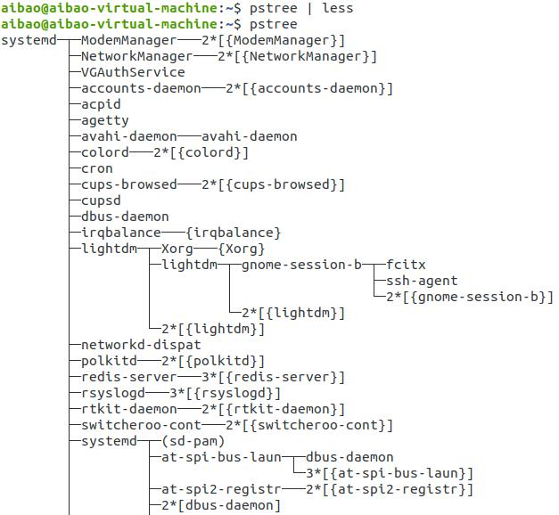

* **Question 2** : what syntax is used on Linux in order to execute a process in the background?

$ nano &

$ jobs -l

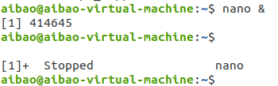

* **Question3** : create a file file1 and write “Hello this is a new file” then get this process *(nano) id*

**$ nano file1**

**$ ps -a | grep nano**

**$ ps -elf | grep nano**

**$ pgrep nano**

* **Question4** : kill the nano process file 1 from different terminal

$ ps pid

* **Qusetion 5:** write a command to force kill process from different terminal

$ kill -9 pid

* **Qusetion 6:** write a command to get the parent of a process then kill process from different terminal

$ ps -efl